**Test Case** **0023**

**System:** VirtuCardsClient & VirtuCardsHost

**Description:** Tests that different Games give the appropriate amount of cards in the beginning.

**Severity:** 2

**Instructions**

**Test 1**

1. Start VirtuCardClient application
2. Click the button labeled “Sign In”
3. Enter “virtucards01@gmail.com” into the text input labeled “Enter email…”
4. Enter “Testing1” into the text input labeled “Enter password…”
5. Press the button labeled “Login”
6. A window should appear saying “Login Success”
7. Press the OK button that appears on that window
8. Start VirtuCardHost application
9. Repeat steps 2-7 but on the VirtuCardHost application
10. The checkbox “Allow Host to Join” should be checked on the host
11. Select from the drop down “Go Fish”
12. Press the Create Game button
13. In the VirtuCardClient application enter the 6-character room code found on the host’s screen into the field labeled “Enter Code…”
14. Press the Join Game button on the client
15. The client should be taken to a waiting screen and the username “Testing0001” should appear on the host.
16. Repeat the steps for the VirtuCard Client on a second device, signing in anonymously
17. Press the Start Game button on the host.

**Expected Result:** Both players should receive five cards in their app.

**Test 2**

1. Start VirtuCardClient application
2. Click the button labeled “Sign In”
3. Enter “virtucards01@gmail.com” into the text input labeled “Enter email…”
4. Enter “Testing1” into the text input labeled “Enter password…”
5. Press the button labeled “Login”
6. A window should appear saying “Login Success”
7. Press the OK button that appears on that window
8. Start VirtuCardHost application
9. Repeat steps 2-7 but on the VirtuCardHost application
10. The checkbox “Allow Host to Join” should be checked on the host
11. Select from the drop down “Go Fish”
12. Press the Create Game button
13. In the VirtuCardClient application enter the 6-character room code found on the host’s screen into the field labeled “Enter Code…”
14. Press the Join Game button on the client
15. The client should be taken to a waiting screen and the username “Testing0001” should appear on the host.
16. Repeat the steps for the VirtuCard Client on a second device, signing in anonymously
17. Press the Start Game button on the host.
18. Make both clients leave the game
19. The Host will go back to the waiting screen, have both clients join once again
20. Press the Start Game button on the host.

**Expected Result:** Both players should receive five cards in their app.

**Test 3**

1. Start VirtuCardClient application
2. Click the button labeled “Sign In”
3. Enter “virtucards01@gmail.com” into the text input labeled “Enter email…”
4. Enter “Testing1” into the text input labeled “Enter password…”
5. Press the button labeled “Login”
6. A window should appear saying “Login Success”
7. Press the OK button that appears on that window
8. Start VirtuCardHost application
9. Repeat steps 2-7 but on the VirtuCardHost application
10. The checkbox “Allow Host to Join” should be checked on the host
11. Select from the drop down “War”
12. Press the Create Game button
13. In the VirtuCardClient application enter the 6-character room code found on the host’s screen into the field labeled “Enter Code…”
14. Press the Join Game button on the client
15. The client should be taken to a waiting screen and the username “Testing0001” should appear on the host.
16. Repeat the steps for the VirtuCard Client on a second device, signing in anonymously
17. Press the Start Game button on the host.

**Expected Result:** Both players should receive no cards in their app. There shouldn’t be a draw card option, and a flip button should be present.

**Test 4**

1. Start VirtuCardClient application
2. Click the button labeled “Sign In”
3. Enter “virtucards01@gmail.com” into the text input labeled “Enter email…”
4. Enter “Testing1” into the text input labeled “Enter password…”
5. Press the button labeled “Login”
6. A window should appear saying “Login Success”
7. Press the OK button that appears on that window
8. Start VirtuCardHost application
9. Repeat steps 2-7 but on the VirtuCardHost application
10. The checkbox “Allow Host to Join” should be checked on the host
11. Select from the drop down “Freeplay”
12. Press the Create Game button
13. In the VirtuCardClient application enter the 6-character room code found on the host’s screen into the field labeled “Enter Code…”
14. Press the Join Game button on the client
15. The client should be taken to a waiting screen and the username “Testing0001” should appear on the host.
16. Repeat the steps for the VirtuCard Client on a second device, signing in anonymously.
17. Press the Start Game button on the host.
18. Press play card on the device who currently is allowed to play their turn.

**Expected Result:** Both players should receive no cards in their app. The option to draw cards and play cards should be present. Playing a card should end the player’s turn. You should be able to draw as many cards as you like.

**Results:**

**Test 1: Go Fish**

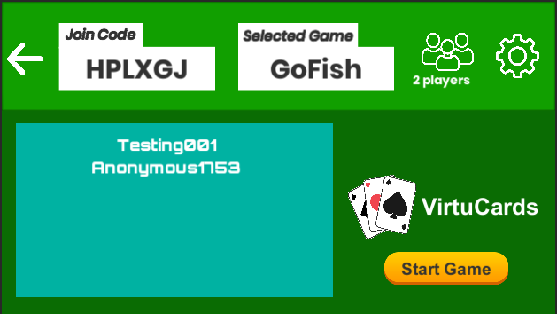

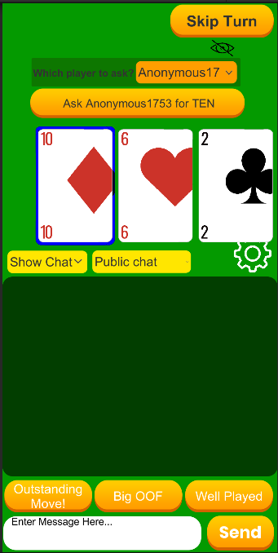

**Test 2: Go Fish**

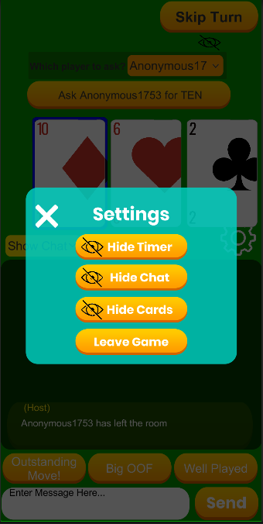

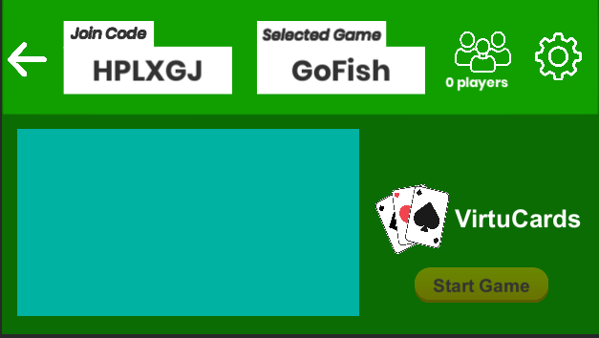

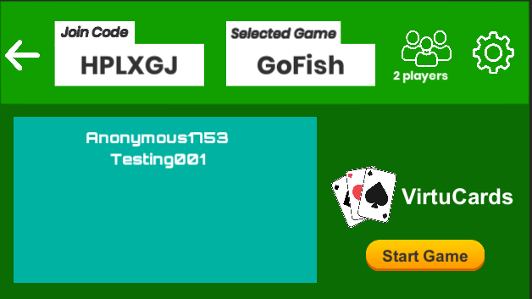

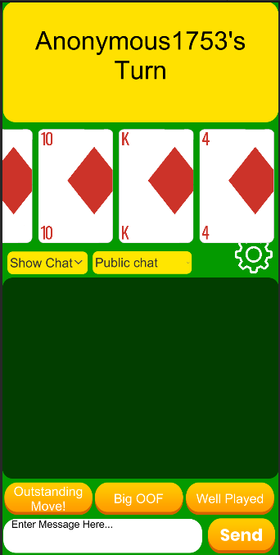

**Test 3: War**

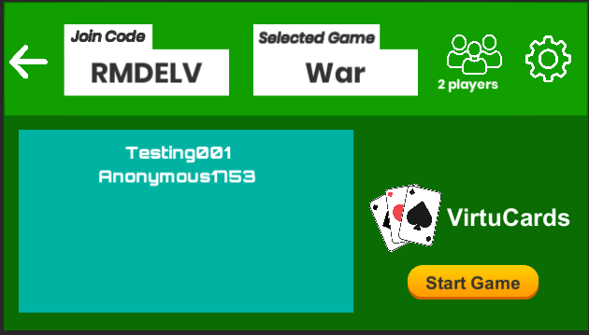

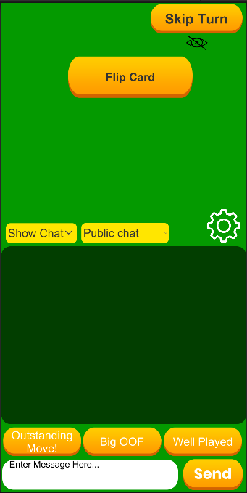

**Test 4: Freeplay**

